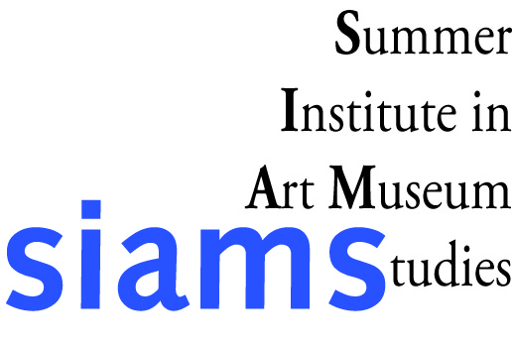
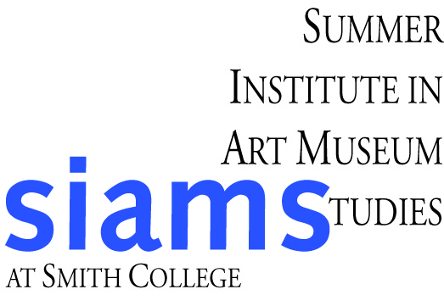
Summer Institute in Art Museum Studies

Reference Directive Form
To the applicant: please express your wishes as indicated below, and send with each of your recommendation requests.

To (Name of reference): | Title:
I appreciate your submitting a letter of recommendation to:
Smith College Summer institute in Art Museum Studies, Smith College Museum of Art, Elm Street at Bedford Terrace, Northampton, MA 01063
Letters must be received by March 9, 2012.

I request that this be an OPEN (NON-CONFINDENTIAL) letter of recommendation.
Signature of candidate: | Date:
OR, I hereby waive my right of access to the attached letter of recommendation.
Signature of candidate: | Date:

